Clinical Psychology
已完成
Website: https://kwh.9u1.net/Services/Clinical-Psychology.html

請確應圖片是否使用這張? 如是, 將會代為購買無水印版
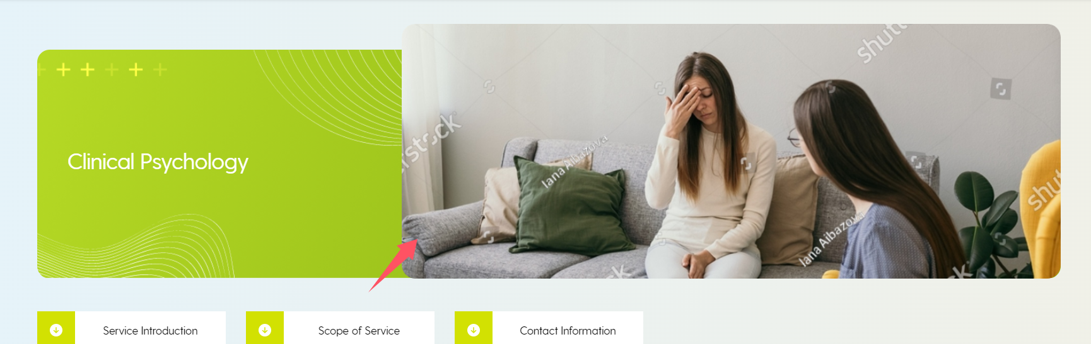
KWH: replace by image “_DSC6549-Enhanced-NR.jpg” at “240927 images”

KWH: Could the hashtags in “Service Introduction” be hidden but still be searchable by the public? If not, please create a new section titled “Keywords” under “Location” and place the hashtags in the “Keywords” section.

KWH: change this photo to “CP Dept8” at “240927 images”
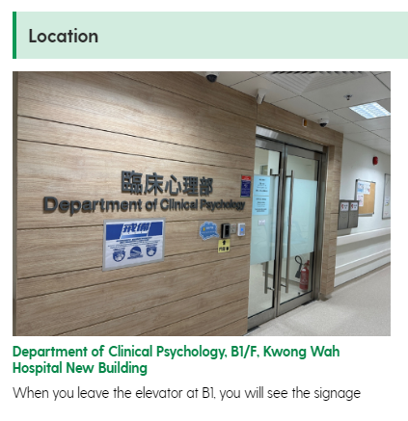

請確應英文版的內容是否已是最終版本? 如是, 將會聯絡翻譯員再較對一次
目前的翻譯文件在:
https://drive.google.com/drive/folders/1_fBmxMrsR_HQOPE4j5ENeBiBpIZEN1et
KWH: please process

Surgery
有關中文的翻譯文字, 請看https://drive.google.com/drive/folders/1_fBmxMrsR_HQOPE4j5ENeBiBpIZEN1et 的Surgery 2024-10-04

Website: https://kwh.9u1.net/Services/Surgery.html

請確應圖片是否使用這張? 如是, 將會代為購買無水印版
請確應現在每一段文字右旁的圖片是否確應選用目前顯示的圖庫圖片, 如是, 將會代為購買無水印版
如下是部分有水印的截圖 (非全部)

有關Breast Centre 及 Vascular Centre, 現在的圖片應是錯誤, 請提供正確
KWH: user will provide the images and select new images from stock later.

請確應英文版的內容是否已是最終版本? 如是, 將會聯絡翻譯員再較對一次
目前的翻譯文件在:
https://drive.google.com/drive/folders/1_fBmxMrsR_HQOPE4j5ENeBiBpIZEN1et
KWH: confirmed to proceed Chinese translation.

Community Nursing Service (Outreach Service)
已完成

Website: https://kwh.9u1.net/Services/Community-Nursing-Service.html

請確應英文版的內容是否已是最終版本? 如是, 將會聯絡翻譯員再較對一次
目前的翻譯文件在:
https://drive.google.com/drive/folders/1_fBmxMrsR_HQOPE4j5ENeBiBpIZEN1et

KWH: one page for 3 service units

user provide the updates as followings with 240930 folder:
1. PDF files- Outreach Service Internet – the webpage layout
- 240930 Outreach Services Internet 2024.pdf
- 240930 Outreach Services Internet 2024_additional update.pptx
2. Word files - Service Information of CNS, CGAS, ICDS (Chinese and English version). Show in the specific language page.
- separated into CGAS/CNS/ICDS chi/eng.pdf
3. Photos -Entrance of CNS & CGAS - we would like to request remove the “green fire exit light” using AI technology before post on the front page. Could vendor help to remove the “green fire exit light”?
- Entrance of CNS & CGAS (1).jpg
- Close up: 3A Door Plate of CNS & CGAS.jpg

